SIMULATION EXPERIMENT – 9
Computer-Aided Design and Optimization of a Microwave Impedance-Matching Network and Frequency-Selective Filter
CO Mapping: CO3
Bloom’s Level: K6 – Create
WK Level: WK4 – Matching/filter design

Objectives of this Experiment
- To design an impedance-matching network for a specified complex microwave load.
- To optimize the matching network for minimum reflection and maximum power transfer.
- To design a microwave filter according to specified cutoff frequency, bandwidth and impedance requirements.
- To evaluate return loss, insertion loss, passband, stopband and bandwidth using simulated frequency responses.

Expected Outcome from this Experiment
- Design and develop an impedance-matching network for a complex load.
- Validate the matching network using reflection coefficient, input impedance, return loss and VSWR.
- Design and simulate a 50 Ω microwave filter with a nominal cutoff frequency of 10 GHz.
- Interpret S11 and S21 responses and compare the calculated results with the specified requirements.
Software Required: MATLAB / ADS / HFSS / CST / Smith Chart Tool
Objective linkage: Design a matching network, optimize reflection, simulate a frequency-selective filter, and evaluate the frequency response against the specified criteria.

Experimental Procedure
A. Impedance Matching: Use ZL = 75 + j25 Ω and Z0 = 50 Ω at 10 GHz. Calculate the load reflection coefficient, return loss and VSWR. Design an ideal matching network and simulate the response from 8 to 12 GHz. Compare the input impedance and reflection before and after matching at 10 GHz.
B. Filter Design: Design a 50 Ω, third-order Butterworth low-pass filter with a cutoff frequency of 10 GHz. Simulate its S11 and S21 responses from 8 to 12 GHz. Determine the −3 dB cutoff frequency, passband/stopband within the sweep, insertion loss, return loss and bandwidth.
C. Performance Evaluation: Compare the simulated cutoff frequency with 10 GHz and calculate percentage deviation. Check the matching return-loss target (>15 dB), passband insertion-loss target (≤2 dB), and filter return-loss target (≥15 dB) separately. Record any requirement that is not met; do not mark it as a pass unless the calculated data supports it.

Input Parameter Table
S.No. | Input Parameter | Symbol / Setting | Value | Unit
1 | Design frequency | f0 | 10 | GHz
2 | Reference impedance | Z0 | 50 | Ω
3 | Load impedance | ZL | 75 + j25 | Ω
4 | Filter cutoff frequency | fc | 10 | GHz
5 | Frequency sweep | fstart–fstop | 8–12 | GHz
6 | Filter response criterion | S21 cutoff | −3 | dB
7 | Target return loss | RL | ≥15 | dB
8 | Maximum passband insertion loss | IL | ≤2 | dB

Formulas Used
- Load reflection coefficient: ΓL = (ZL − Z0)/(ZL + Z0).
- Reflection coefficient magnitude: |ΓL| = abs(ΓL).
- Return loss: RL = −20 log10(|Γ|) dB.
- VSWR: (1 + |Γ|)/(1 − |Γ|).
- Lossless transmission-line input impedance: Zin = Z0 (ZL + jZ0 tan βl)/(Z0 + jZL tan βl).
- Filter insertion loss: IL = −20 log10(|S21|) dB.
- Filter return loss: RL = −20 log10(|S11|) dB.
- Bandwidth: BW = fH − fL, where fL and fH are the selected passband edges.
- Percentage deviation: |simulated − theoretical| / |theoretical| × 100%.
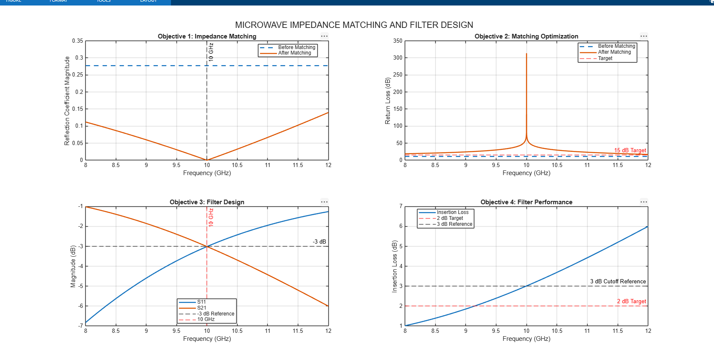

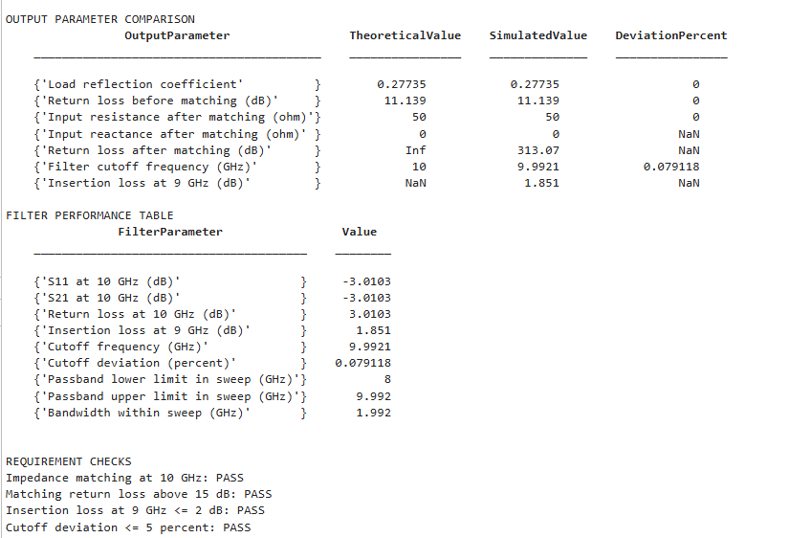

Output Parameter Table (to be completed from MATLAB results)
S.No. | Output Parameter | Theoretical / Expected Value | Simulated Value | % Deviation
1 | Load reflection coefficient magnitude | 0.2774 for ZL = 75 + j25 Ω | Record from MATLAB | Calculate
2 | Input impedance after matching at 10 GHz | Approximately 50 + j0 Ω | Record from MATLAB | Calculate
3 | Return loss before matching | Approximately 11.14 dB for specified load | Record from MATLAB | Calculate
4 | Return loss after matching | >15 dB target | Record from MATLAB | Not applicable to target
5 | Filter cutoff frequency | 10 GHz | Record from S21 = −3 dB crossing | Calculate
6 | Insertion loss in passband | ≤2 dB target | Record from MATLAB | Compare with limit
7 | Filter return loss in passband | ≥15 dB target | Record from MATLAB | Compare with limit
8 | Passband / stopband | Determine from S21 response | Record frequency limits | N/A
9 | Bandwidth within 8–12 GHz sweep | From selected passband edges | Record from MATLAB | N/A

Key Conditions and Threshold Values
Parameter | Requirement | How to verify
Matching frequency | 10 GHz | Check Zin and |Γ| at 10 GHz.
Input impedance after matching | Close to 50 + j0 Ω | Check real(Zin) and imag(Zin).
Matching return loss | >15 dB desirable | Evaluate RL after matching at 10 GHz.
Filter cutoff | Approximately 10 GHz | Find S21 = −3 dB crossing.
Passband insertion loss | ≤2 dB | Check IL across the defined passband.
Filter return loss | ≥15 dB in required passband | Check −S11(dB) across the passband.
Stopband | Below −3 dB transmission criterion | Identify frequencies where S21(dB) < −3 dB.

MATLAB Code
The following standalone MATLAB script generates the four required 2D graphs in one 2×2 layout and prints the main output values. It uses an ideal third-order Butterworth low-pass prototype and an ideal L-match calculation at the design frequency. The matching and filter are analyzed as separate circuits.
clc; clear; close all;

%% Input parameters
Z0 = 50;
ZL = 75 + 1i*25;
f0 = 10e9;
fc = 10e9;
f = linspace(8e9,12e9,4001);
w = 2*pi*f;
wc = 2*pi*fc;

%% Objective 1: Load reflection before matching
GammaL = (ZL-Z0)/(ZL+Z0);
GammaBefore = abs(GammaL);
RLBefore = -20*log10(GammaBefore);
VSWRBefore = (1+GammaBefore)/(1-GammaBefore);

%% Ideal L-match: shunt susceptance across load, then series reactance
YL = 1/ZL;
G = real(YL);
BL = imag(YL);
Btotal = sqrt(G/Z0-G^2);
Bsh = Btotal-BL;
Zparallel = 1/(G+1i*Btotal);
Xs = -imag(Zparallel);

if Bsh >= 0
Csh = Bsh/(2*pi*f0); Lsh = NaN;
else
Lsh = -1/(2*pi*f0*Bsh); Csh = NaN;
end
if Xs >= 0
Lseries = Xs/(2*pi*f0); Cseries = NaN;
else
Cseries = -1/(2*pi*f0*Xs); Lseries = NaN;
end

Ymatch = 1/ZL + 1i*Bsh*(w/(2*pi*f0));
Zparallel_f = 1./Ymatch;
if ~isnan(Lseries)
Zseries_f = 1i*w*Lseries;
else
Zseries_f = 1./(1i*w*Cseries);
end
Zin = Zparallel_f + Zseries_f;
GammaAfter = abs((Zin-Z0)./(Zin+Z0));
RLAfter = -20*log10(max(GammaAfter,eps));
[~,i0] = min(abs(f-f0));

%% Objective 3: Ideal third-order Butterworth low-pass, 50-ohm ports
L1 = Z0/wc;
C2 = 2/(Z0*wc);
L3 = Z0/wc;
S11 = zeros(size(f));
S21 = zeros(size(f));

for k = 1:numel(f)
M1 = [1 1i*w(k)*L1; 0 1];
M2 = [1 0; 1i*w(k)*C2 1];
M3 = [1 1i*w(k)*L3; 0 1];
M = M1*M2*M3;
A = M(1,1); B = M(1,2); C = M(2,1); D = M(2,2);
den = A+B/Z0+C*Z0+D;
S11(k) = (A+B/Z0-C*Z0-D)/den;
S21(k) = 2/den;
end

S11dB = 20*log10(max(abs(S11),eps));
S21dB = 20*log10(max(abs(S21),eps));
ReturnLossFilter = -S11dB;
InsertionLoss = -S21dB;

idx = find(S21dB <= -3,1,'first');
if isempty(idx)
fcSim = NaN;
elseif idx == 1
fcSim = f(1);
else
fcSim = interp1(S21dB(idx-1:idx),f(idx-1:idx),-3);
end
if isnan(fcSim)
CutoffDeviation = NaN;
else
CutoffDeviation = abs(fcSim-fc)/fc*100;
end

Passband = S21dB >= -3;
if any(Passband)
fL = min(f(Passband));
fH = max(f(Passband));
BW = fH-fL;
else
fL = NaN; fH = NaN; BW = NaN;
end

%% Output values
fprintf('\\nEXPERIMENT 9 OUTPUTS\\n');
fprintf('|Gamma before matching| = %.4f\\n',GammaBefore);
fprintf('Return loss before matching = %.3f dB\\n',RLBefore);
fprintf('VSWR before matching = %.3f\\n',VSWRBefore);
fprintf('Zin at 10 GHz = %.3f %+.3fj ohm\\n',real(Zin(i0)),imag(Zin(i0)));
fprintf('Return loss after matching at 10 GHz = %.3f dB\\n',RLAfter(i0));
fprintf('S11 at 10 GHz = %.3f dB\\n',S11dB(i0));
fprintf('S21 at 10 GHz = %.3f dB\\n',S21dB(i0));
fprintf('Filter return loss at 10 GHz = %.3f dB\\n',ReturnLossFilter(i0));
fprintf('Insertion loss at 10 GHz = %.3f dB\\n',InsertionLoss(i0));
fprintf('Simulated cutoff = %.4f GHz\\n',fcSim/1e9);
fprintf('Cutoff deviation = %.4f %%\\n',CutoffDeviation);
fprintf('Passband within sweep = %.4f to %.4f GHz\\n',fL/1e9,fH/1e9);
fprintf('Bandwidth within sweep = %.4f GHz\\n',BW/1e9);

%% Four required graphs in one 2x2 layout
figure('Color','w','Position',[80 80 1200 750]);

subplot(2,2,1);
plot(f/1e9,GammaBefore*ones(size(f)),'--','LineWidth',1.6); hold on;
plot(f/1e9,GammaAfter,'LineWidth',1.6);
xline(10,':k','10 GHz'); grid on; xlim([8 12]);
xlabel('Frequency (GHz)'); ylabel('|Gamma|');
title('Objective 1: Impedance Matching');
legend('Before matching','After matching','Location','best');

subplot(2,2,2);
plot(f/1e9,RLBefore*ones(size(f)),'--','LineWidth',1.6); hold on;
plot(f/1e9,RLAfter,'LineWidth',1.6);
yline(15,'--r','15 dB target'); grid on; xlim([8 12]);
xlabel('Frequency (GHz)'); ylabel('Return Loss (dB)');
title('Objective 2: Matching Optimization');
legend('Before matching','After matching','Target','Location','best');

subplot(2,2,3);
plot(f/1e9,S11dB,'LineWidth',1.6); hold on;
plot(f/1e9,S21dB,'LineWidth',1.6);
yline(-3,'--k','-3 dB'); xline(10,':r','10 GHz');
grid on; xlim([8 12]);
xlabel('Frequency (GHz)'); ylabel('Magnitude (dB)');
title('Objective 3: Filter Design');
legend('S11','S21','-3 dB reference','10 GHz','Location','best');

subplot(2,2,4);
plot(f/1e9,InsertionLoss,'LineWidth',1.6); hold on;
yline(2,'--r','2 dB limit'); yline(3,'--k','3 dB at cutoff');
grid on; xlim([8 12]);
xlabel('Frequency (GHz)'); ylabel('Insertion Loss (dB)');
title('Objective 4: Filter Performance');
legend('Insertion loss','2 dB limit','3 dB cutoff reference','Location','best');

sgtitle('Experiment 9: Microwave Impedance Matching and Filter Design');

Result
The impedance-matching network and third-order Butterworth low-pass filter are modeled in MATLAB. The load reflection coefficient is calculated from the specified complex load. The simulated input impedance, return loss, VSWR, S11, S21, insertion loss, cutoff frequency and bandwidth are printed by the script and shown in the four 2D plots. Enter the values produced by your MATLAB run into the output parameter table.

Conclusion
This experiment demonstrates computer-aided design and evaluation of a microwave impedance-matching network and frequency-selective filter. The matching network should be judged at 10 GHz using input impedance and reflection. Filter acceptance must be assessed independently: the −3 dB cutoff criterion, ≤2 dB passband insertion-loss target and ≥15 dB passband return-loss target may not all be satisfied by the initial ideal prototype. Any unmet criterion should be reported honestly and addressed by redesign or optimization.
Note: For ZL = 75 + j25 Ω and Z0 = 50 Ω, the mathematically calculated load reflection magnitude is approximately 0.2774 and the corresponding return loss is approximately 11.14 dB. This differs from the 0.3333 and 9.54 dB figures in the supplied experiment sheet; use the stated complex load for calculations and clarify the discrepancy with the instructor.
REFLECTION:
The experiment provided practical insight into microwave impedance matching and filter design using MATLAB simulations. The analysis of S-parameters, return loss, insertion loss, and cutoff frequency enhanced my understanding of microwave system performance and design optimization.

